**SSN-CSI Student Chapter**

**Python and Wisdom Education Workshop**

The Python and Wisdom Education Workshop was conducted every Saturday for 3 hours from September 2019 to November 2019. A total of eight sessions were conducted exclusively for first years. The workshop was organised under the guidance of Dr. A. Chamundeswari and Dr. J.Suresh. The speakers for the workshop were

1. **Sreenivas Gupta,** BTech CSE IITM, Software Developer, Chronus Software India Pvt. Ltd. Chennai.
2. **Giridhar S,** BTech CSE IITM, Software Developer, Quantitative Brokers, Chennai.

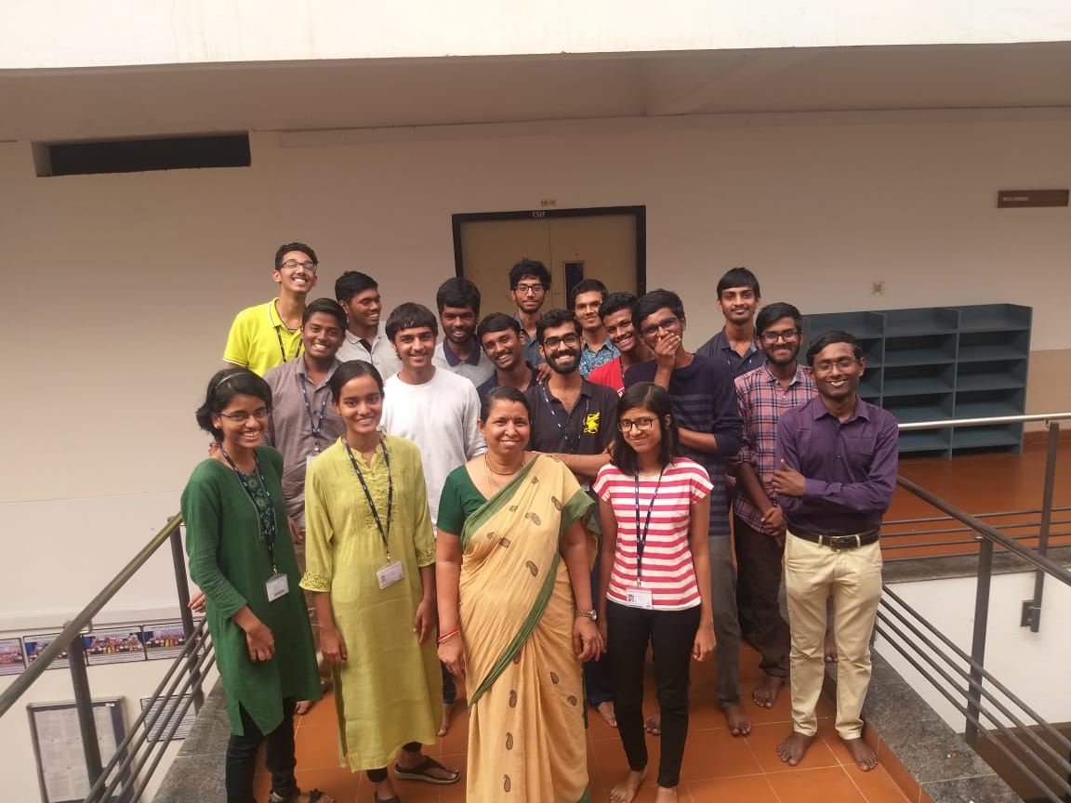

The participants of the workshop was selected by means of aptitude tests hosted by the speakers themselves and students who fared well in the qualifying tests were eligible for the workshop. The qualifying tests comprised of mostly general aptitude questions from different domains and logical riddles. The invitation for the workshop was well received by the fresher's with over 90 students taking the qualifying test, out of which 50 students were shortlisted for the workshop. In each of the 3-hour session students were taught how to program in python from scratch and also covered topics beyond their University syllabus. In addition to this they were also taught wisdom education. Programming exercises were also given at the end of each session to boost their programming skills. After a few initial sessions the students were asked to take up mini-projects based on their area of interest using Python with the speakers mentoring them. The projects were done by the students in pairs while some did alone. The projects were developed within a span of one and a half month and almost all the projects came out well. Certificates were issued to people who came out with good results during the course of the workshop.

Krijeshan G, III year CSE B